

Department of Computer
Science

Faculty of
Computing

UNIVERSITI TEKNOLOGI MALAYSIA

SUBJECT NAME: | COMPUTER ORGANIZATION AND ARCHITECTURE
SUBJECT CODE: | SECR 1033
SEMESTER: | 2 - 2023/24
LAB TITLE: | Programming 3: Interactive Usage of Link Libraries and Comparison & Conditional Jumps PART 1: Interactive Usage of Link Libraries  PART 2: Comparison & Conditional Jumps
INSTRUCTION: | Complete the lab activities in Part 1C and Part 2C and divide loads among group member equally
STUDENT INFO : | Name : | IMAN ABADI BIN MOHD NIZWAN
 | Metric No : | A23CS0084
 | Section: | 03
 | Email : | imanabadi@graduate.utm.my
STUDENT INFO : | Name : | MUHAMMAD NAIM BIN ABDULLAH
 | Metric No : | A23CS0134
COMMENTS: | Section : 03  Email : naim04@graduate.utm.my
Prepared by: HKM, MMA, MFR (revised 2024)
Computer Organization and Architecture
SECR 2033
FLOW CHART OF PART 1C
Program 1
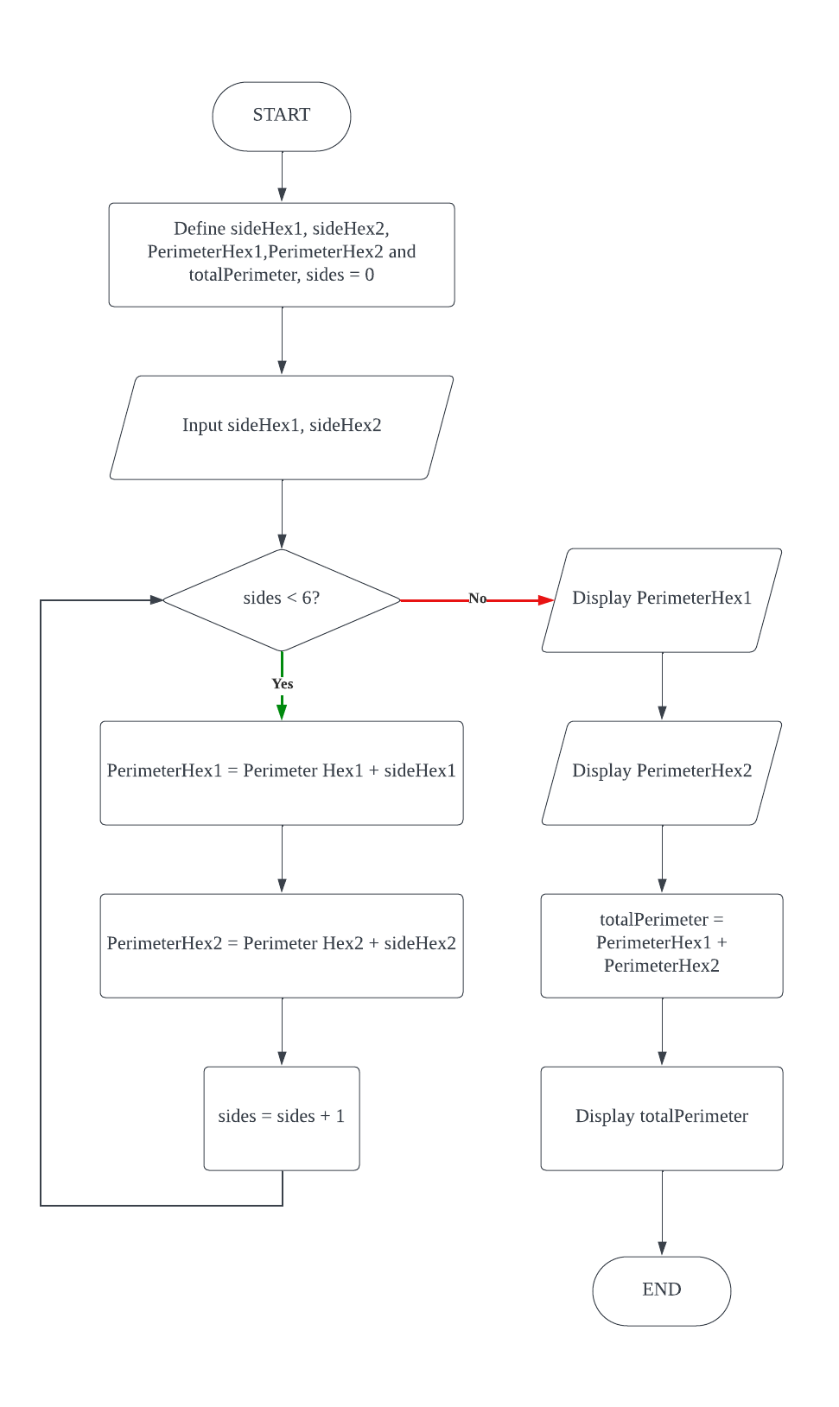
Program 2

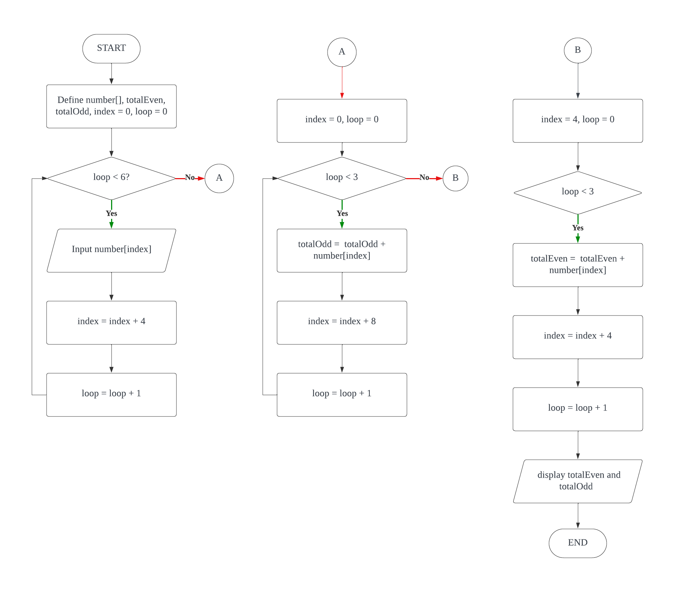

FLOWCAHRT OF PART 2C

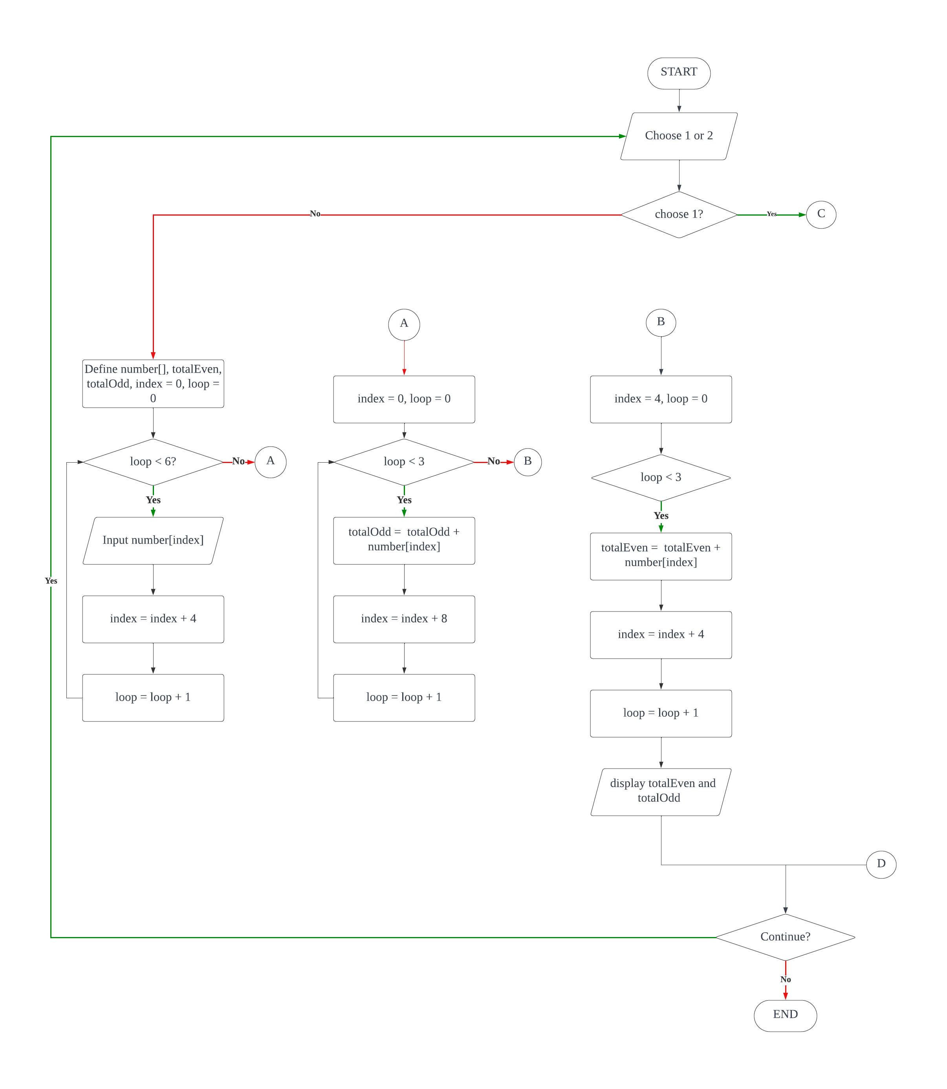

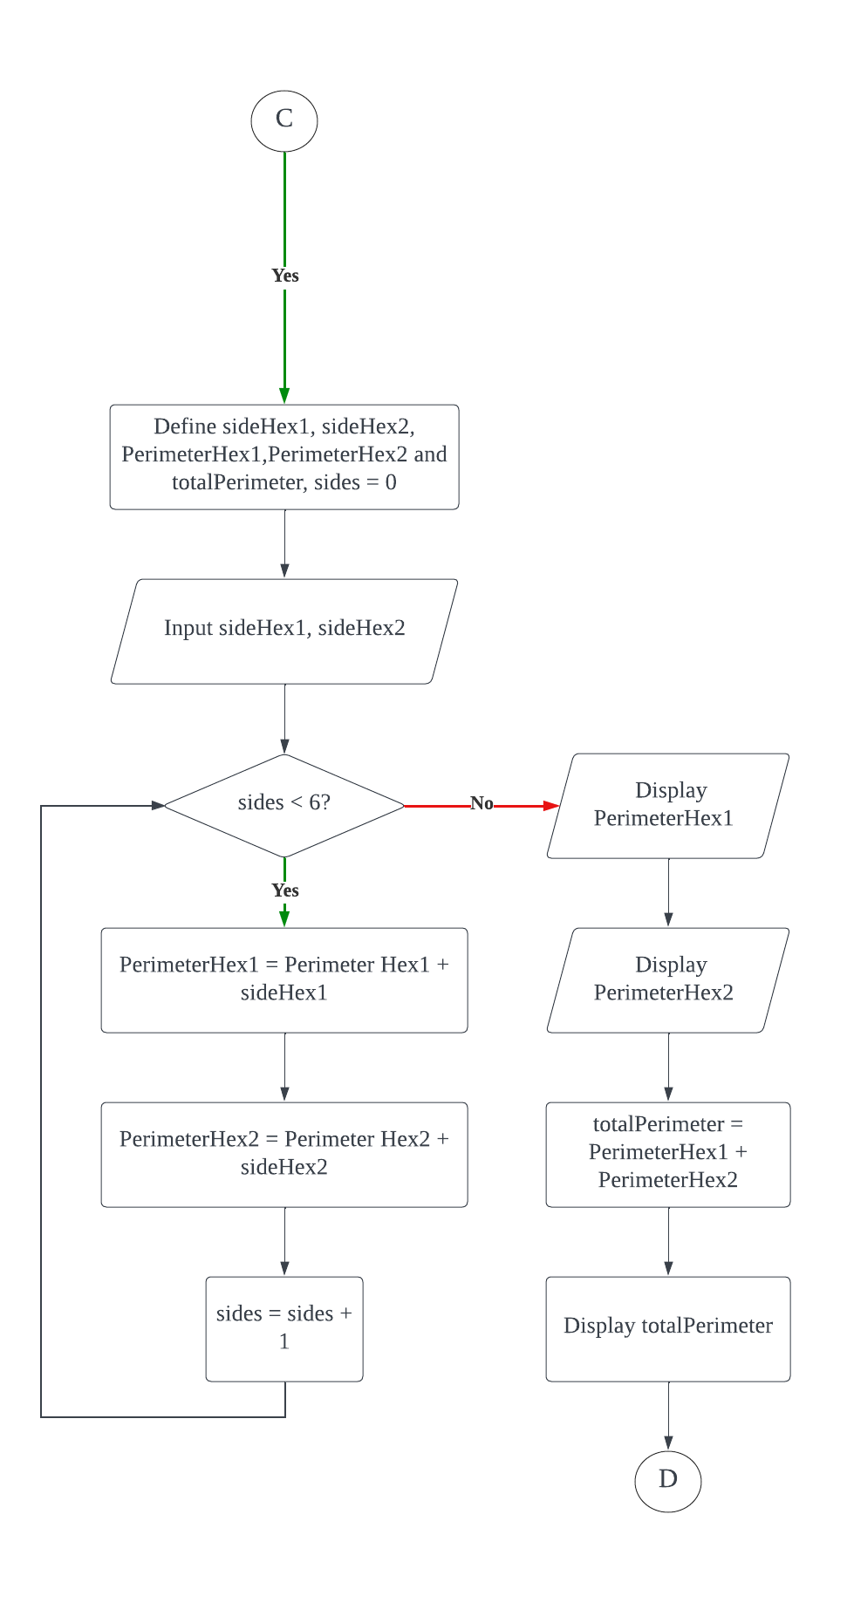
VIDEO LINK :
https://drive.google.com/drive/folders/1UPGeDep5WA92G1iwuYQw0D-VD8Dv3WuU?usp=sharing

